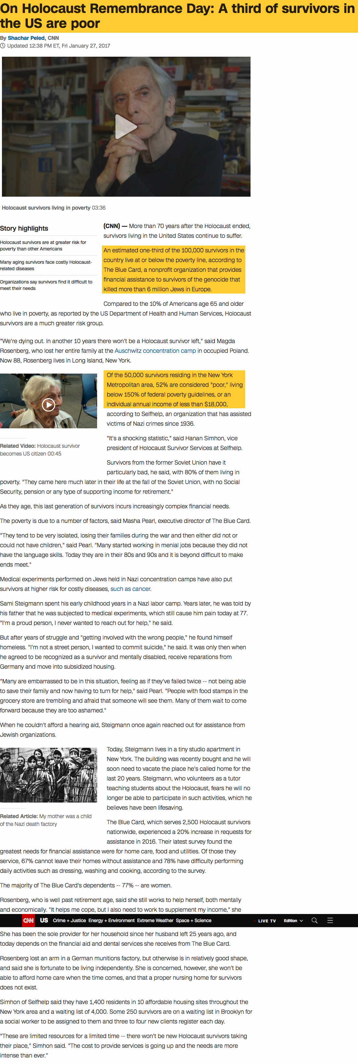

For a poverty-stricken individual an extra $120 per month often means a gas and phone bill will be paid; additionally, the knowledge that a payment will always arrive each month provides a degree of mental and emotional comfort.

The Blue Card typically gives survivors $100 per month. The Polish pension provides approximately $120 per month.