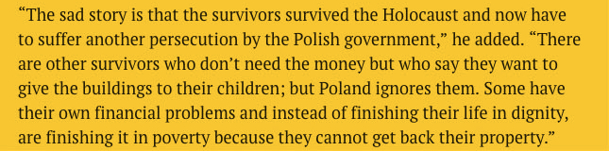

The Polish pension will not alleviate poverty, but it will add to the dignity of the survivor as it shows that Poland is willing to recognize their plight and provide restitution even though the property issue may not be resolved in survivors’ lifetimes.